Graeme Priddle & Melissa Engler
Over the last two decades woodturning has undergone a revolution. It’s no longer just about turning wood on a lathe. Today wood is carved, inlaid, etched, painted and burned. It’s an exciting medium and artists such as Melissa and Graeme are at its forefront.
Graeme Priddle is from New Zealand. He has traveled and taught woodturning and sculpture workshops around the globe since the early ‘90’s. His style is intricate and intriguing, most often relating to his native New Zealand culture or his experiences with boats and travels.
Melissa Engler is a woodworker/sculptor based in Asheville, NC. She holds a Bachelor of Arts in sculpture from the University of North Carolina at Asheville and is a graduate of the Haywood Community College Professional Crafts Program in furniture. Her work conveys our connection to the environment and evokes an awareness of its tenuous state.
Together, they teach nationally and internationally.

Dan Tilden
Dan turns his pieces to retain the most natural features possible. Dan says, “using a natural edge opening, drying wet wood to warp and move, and using a knot or void in the shape adds character and lets the piece speak for itself.”

Location:
Thurston County Fairgrounds
Thurston Expo Center
3054 Carpenter Road
Lacey, WA 98503

Directions:
I-5 Southbound: Take Exit 109, turn left onto Martin Way. Take Martin Way to Carpenter Road. Turn right onto Carpenter Road and follow approximately 3 miles to the fairgrounds on your left.

I-5 Northbound: Take Exit 109, turn right onto Martin Way. Take Martin Way to Carpenter Road. Turn right onto Carpenter Road and follow approximately 3 miles to the fairgrounds on your left.

The Expo Center will be the first building on your left. Free parking.

Thank You Sponsors!
D-Way Tools
Rockler Woodworking – Tukwila
Sumner Woodworker Store
Woodcraft – Seattle

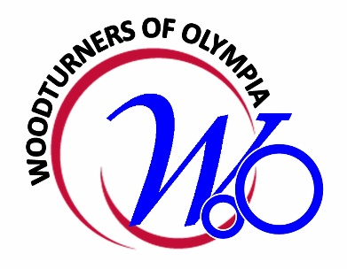
Woodturners of Olympia
Presents
2019
Symposium and Workshops
Featuring

Graeme Priddle
and
Melissa Engler
with Dan Tilden
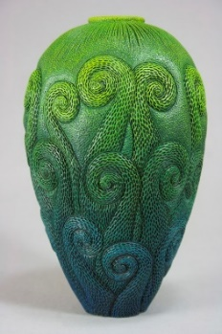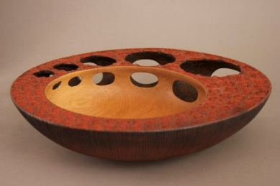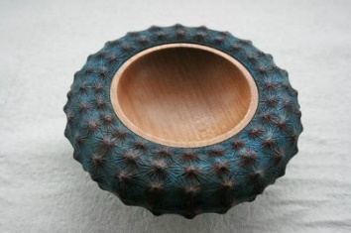
SYMPOSIUM

Saturday September 21, 2019
Doors Open at 7:00AM
Symposium 8:00AM – 5:00PM

Dan Tilden
8:00 - 9:30 Natural Edge Turning

Graeme and Melissa
Basic Bowls and Embellishments
10-12 Turning Basic Bowls
12-1 Lunch
1-4:30 Embellishments
Carving, texturing, burning, coloring and finishing
4:30-5 Closing and Door Prizes

FOOD
Morning pastries, lunch, and afternoon break snacks will be catered by Panera Bread. Beverages will be provided also.

For lunch, a variety of sandwiches and salads will be provided. Make your choice when you register.

WORKSHOPS
Each day will be customized to your interests and skill level. Register for one, two, three or all four days.

Sunday and Monday Sept.22 & 23
Focus: “Basic Bowls and Embellishments”
The workshop will start with a focus on basic bowl turning skills to create a canvas for the application of embellishments. Graeme will help new turners while Melissa will take experienced turners forward with the embellishment techniques.

Tuesday & Wednesday Sept.24 & 25
Focus: “Surface, Surface”
Students will be led through a myriad of surface treatments and embellishment possibilities. This class will cover:
- Design and influences to personalize your work
- Tool selection, sharpening and safety
- Wood selection
- Rotary/hand carving and texturing techniques
- Wood-burner detailing and texturing
- Coloring and finishing techniques

Sign up for one, two, three or all four days. Whatever you choose, you will come away with new skills and a great experience.

Each day is limited to eight participants.
Register early to ensure your spot!
REGISTRATION & FEES

SYMPOSIUM

Adults
Before Sept. 1 $90
After Sept. 1 $100

Students
(K-12 and registered $15
college students)

WORKSHOPS
1 Day $150
2 Days $275
3 Days $400
4 Days $500

Register on-line:
https://woodturnersofolympia.regfox.com/woo-symposium

Need assistance registering? Contact:
George Macauley 360-918-2304
gcmacauley@comcast.net

Woodturners of Olympia is a private/non-profit 501.c3 organization dedicated to promoting and providing educational opportunities related to the art and craft of wood turning.

For information about our organization and how to become a member go to:
www.woodturnersofolympia.org

